Input/Output Pad

- Output Pad :

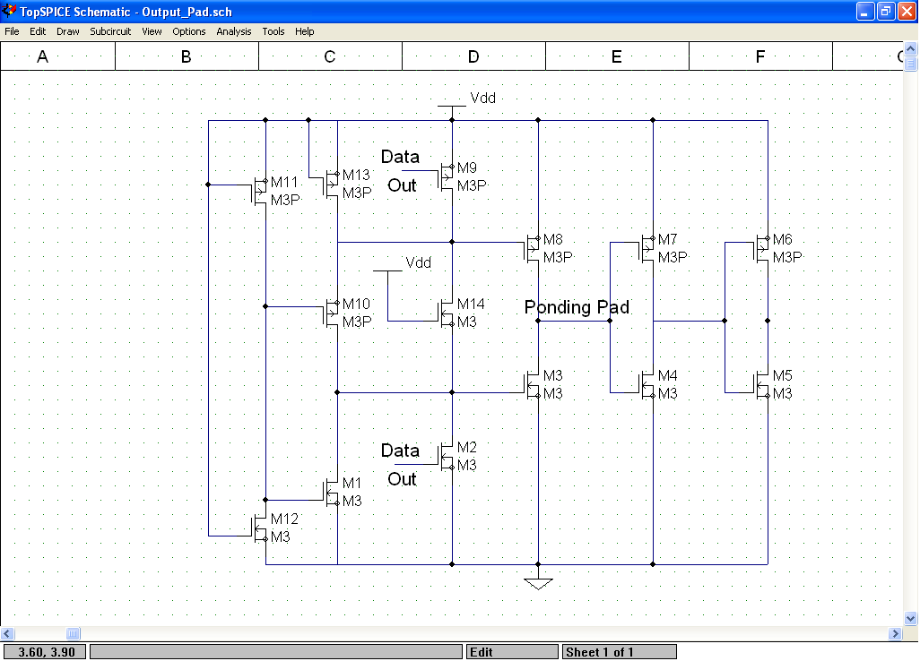

In the output Pad, the Output enable is connected to Vdd to enable the Data out to the Pounding Pad. The two inverters on the right have no importance in the circuit.

When using the cell, ignore the DataIN, Data_IN_Buffered and Data_IN_Unbuffered. Don’t connect the OE to Vdd because it is internally connected to Vdd. And connect the Data out to your core using Metal 2 Layer.

- Input Pad:

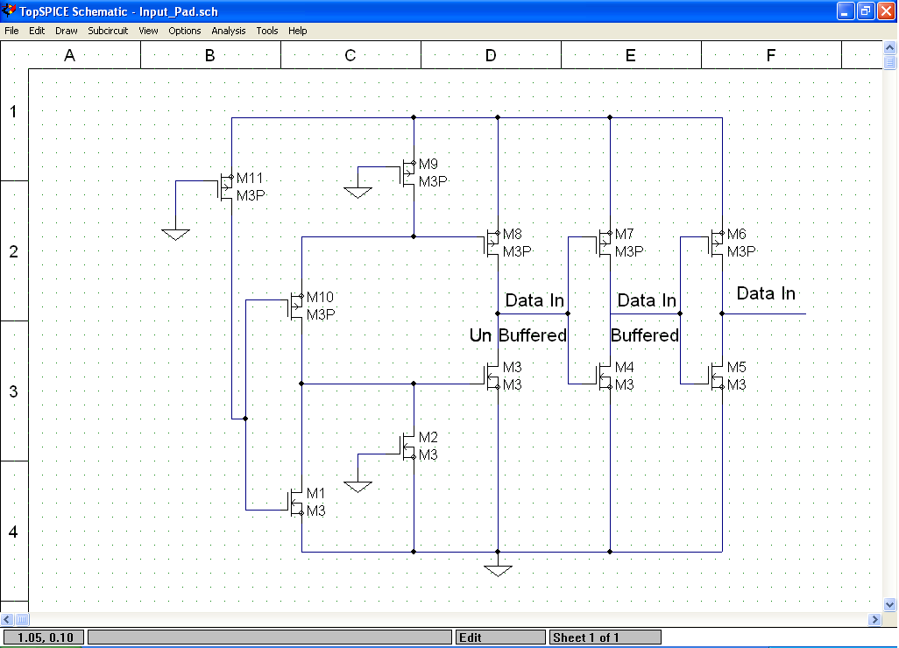

The Pounding Pad is connected directly to Terminal “ Data IN Unbefferd “ while The Data In Buffered is the output of the first inverter on the right. Data In is the output of the last inverter. So, The Data In buffered is an inverted version of the input.
In the circuit the Data Out is connected to the ground ,also the Output Enable is connected to Gnd.

When using the cell, connect the Data In using Metal2 layer to your core. And don’t use the Data Out or Output Enable because they are internally connected to the ground.

Hint,
The layout of the Input and output Pad seem to be the same, but indeed they have some slight difference from inside where The Unused Pins are terminated.

